Registering a New Organization
Contents
Registering a New Organization 1
Step 1 1
Step 2 2
Step 3 2
Step 4 3
Step 5 4
Step 6: 5

Are you looking to start a new organization on campus? Registering through Involved@SU will allow you to create events for your organization, manage your organization's membership, share information, and communicate efficiently with members.

Step 1
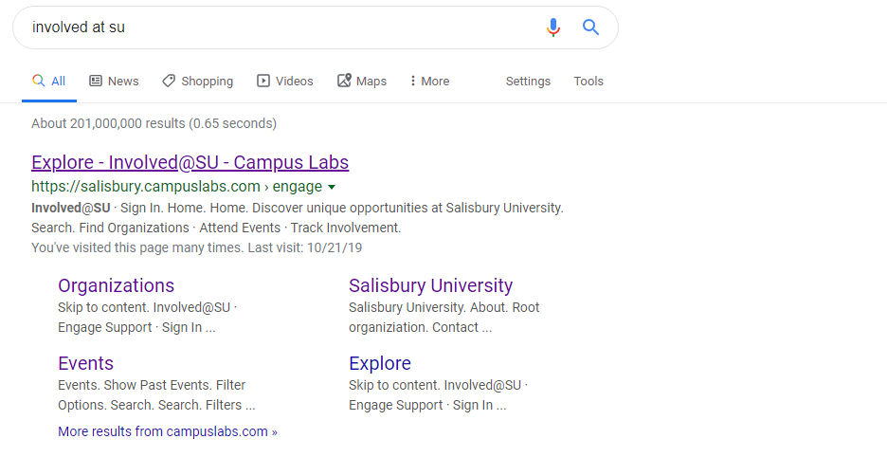
Start by initiating a Web search for “Involved @ SU”

Step 2
To register a new organization, navigate to the Organizations tab at the top of your Involved@SU homepage.

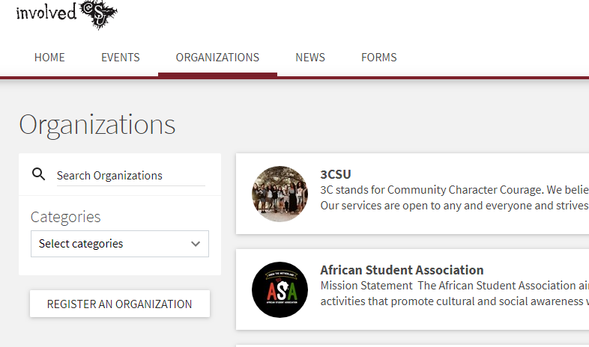
Step 3
Select the ‘Register An Organization’ button.

Step 4
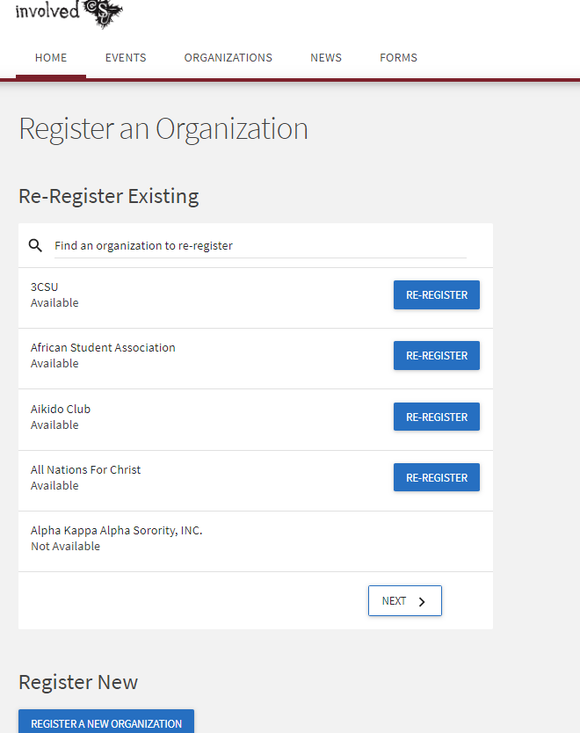
If Registrations for new organizations are available at this time, you will see a button that says Register a New organization on the left side of the page underneath the existing options.

Step 5
Clicking ‘Register a New Organization’ will start your organization registration process.
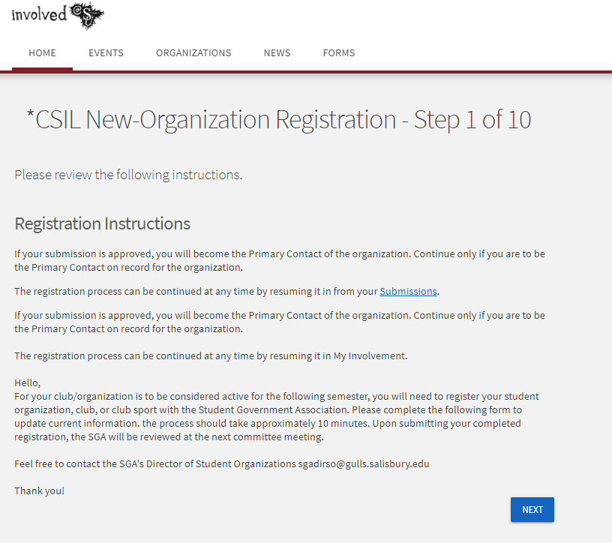
From there, you will be asked to complete a number of steps. Click Next at the bottom of each page when you have completed the step to progress to the next step in the process. You will have the chance to review each step before submitting your completed registration. When you are finished, click Submit for Approval to send your request to the Director of Student of Organizations of the Student Government Association.

Step 6:
At this point you should meet with the Director of Student Orgs. if you have not already. The holder of this position and their committee will review your application and provide an approval or denial. If denied, the committee will provide feedback on how to fix any issues with the application.
If you have further Questions please contact one of the following:
Director of Student Orgs: sgadirso@gulls.salisbury.edu
GA for Student Group Services: swstudactivities2@salisbury.edu

